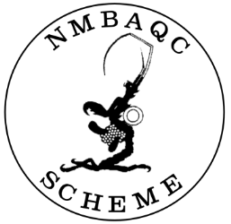

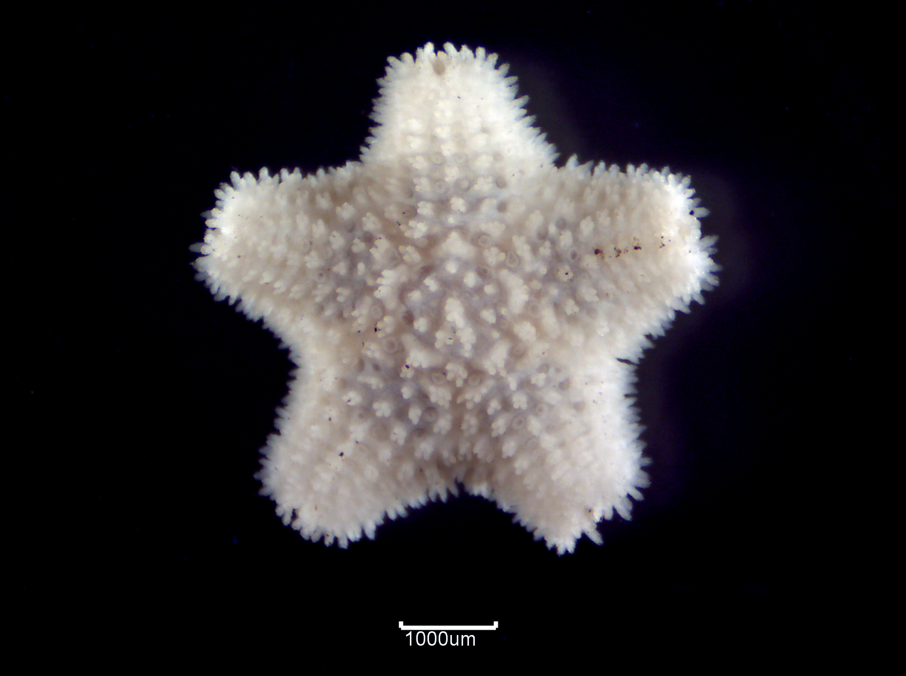 | 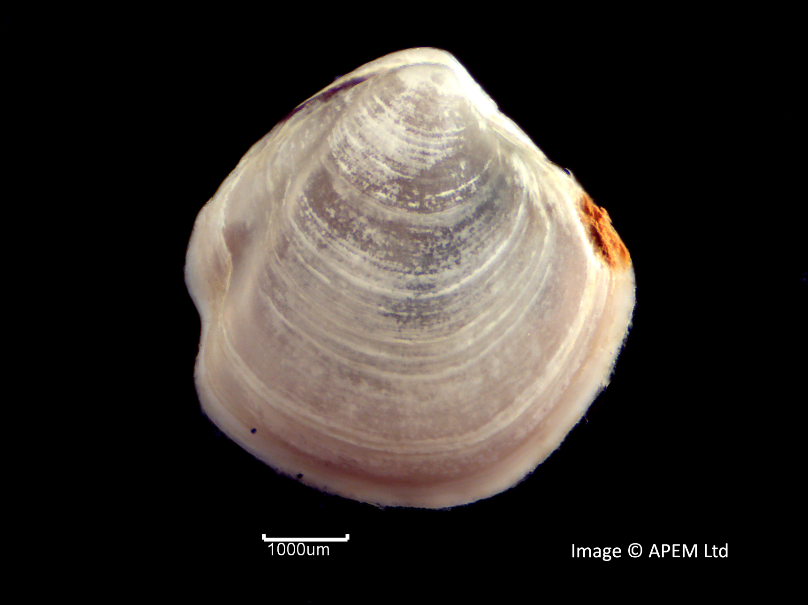
Asterina gibbosa ©APEM | Thyasira flexuosa ©APEM

2025 Benthic Invertebrate Taxonomic Workshop for Beginners
Expression of Interest / Booking Form

24th November – 28th November 2025
APEM Marine Laboratory, Unit 3 the Orbital Centre, Icknield Way, Letchworth Garden City, SG6 1ET, England, UK

The NMBAQC Scheme was set up to provide quality control/assurance to the macrobenthic invertebrate elements of the Clean Seas Environmental Monitoring Programme (CSEMP; formerly the NMMP); it has since provided the external quality assurance for statutory monitoring to report to Government and the EU. These reporting requirements have led to the NMBAQC diversifying into other biological disciplines. The elements of the Scheme are detailed in the NMBAQC website.

The macrobenthic component aims to improve the quality of macrobiota identification through practical workshops. Workshops are tailored to meet some of the current training needs reflected by participating laboratories in the Scheme.

The 2025 Workshop aims to:
- provide an introduction to the best practice processing methods for macrobenthic samples with practical training on the extraction of fauna from various types of sediment;
- educate early career benthic biologists and enthusiasts in the identification of major faunal groups encountered in UK and North-East Atlantic waters, with a combination of theory sessions from experienced marine scientists and practical sessions with over 5,000 reference lots from our Marine Reference Collection;
- provide a venue for relaxed, but effective and supportive training.

The expression of interest form below is for places at the 2025 NMBAQC Scheme Taxonomic Workshop for Beginners. All are welcome; however, places are limited so priority will be given to current NMBAQC participants.

Please express your interest by 27th October 2025 by completing the form overleaf. Note places are reserved on a first come first served basis.
Please note that, as this is a self-funded workshop. Any subsequent request to cancel must be received by the 27th October 2025. After this date, any participant cancellations will be non-refundable in the event that the workshop proceeds. The workshop will be confirmed on the 31st October 2025. It is strongly advised that participants do not book travel and accommodation until the workshop has been confirmed.

A full refund of the participation fees will be provided if the workshop is cancelled by the organisers on or after the 1st November 2025. However, the scheme will not be responsible for covering any costs associated with the workshop (e.g. travel and accommodation) in the event of cancellation, so please ensure you have the necessary insurance in place should this occur.

The Date:
24th November – 28th November 2025

The Venue:
APEM Marine Laboratory, Unit 3 Orbital Centre, Icknield Way, Letchworth, Hertfordshire, SG6 1ET, England, UK.

The Organisers:
APEM Ltd. on behalf of the North East Atlantic Marine Biological Analytical Quality Control (NMBAQC) Committee

General format:

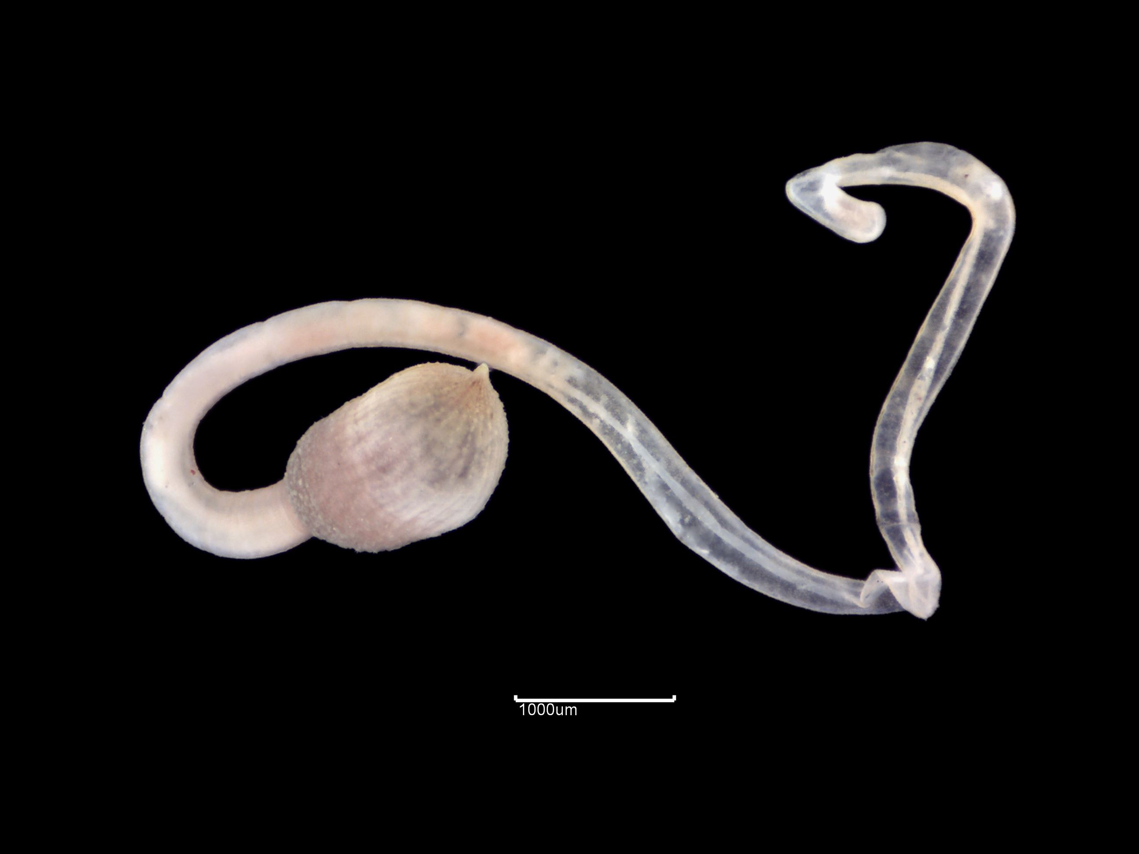 | The workshop will last 5 days and, after a brief introduction on all the faunal groups that can be found in a marine/estuarine macrobenthic sample, we will cover the four Major Taxonomic Group, Polychaeta, Crustacea, Mollusca (Bivalvia and Gastropoda) and Echinodermata, in more detail.
Onchnesoma steenstrupii ©APEM

Each of the four Major Groups will be treated on separate day, with an introductory talk in the morning to provide an overview of the principal morphological characters and Families, and practical observation of specimens from our Reference Collection in the afternoon. | 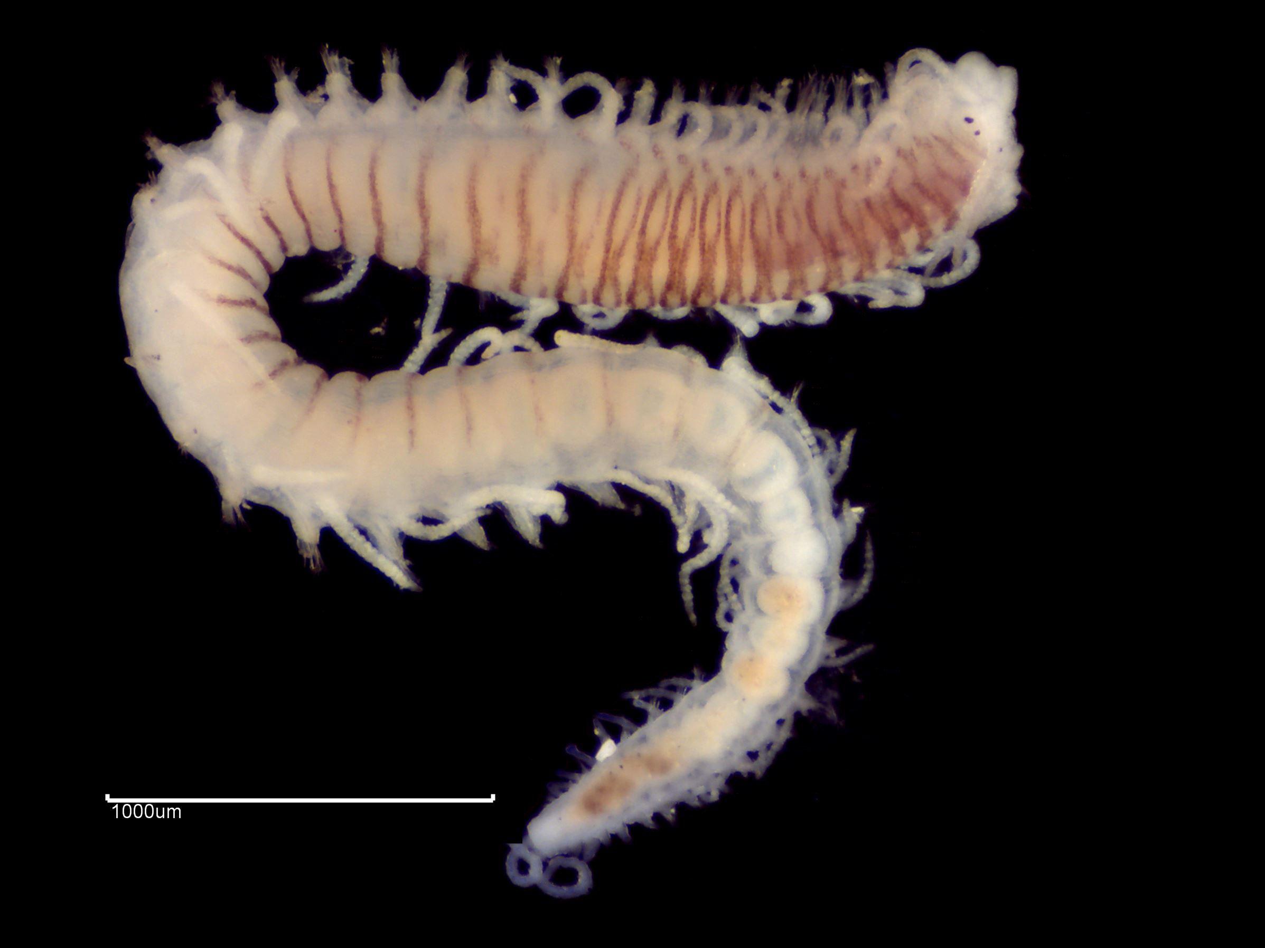
 | Syllis variegata ©APEM
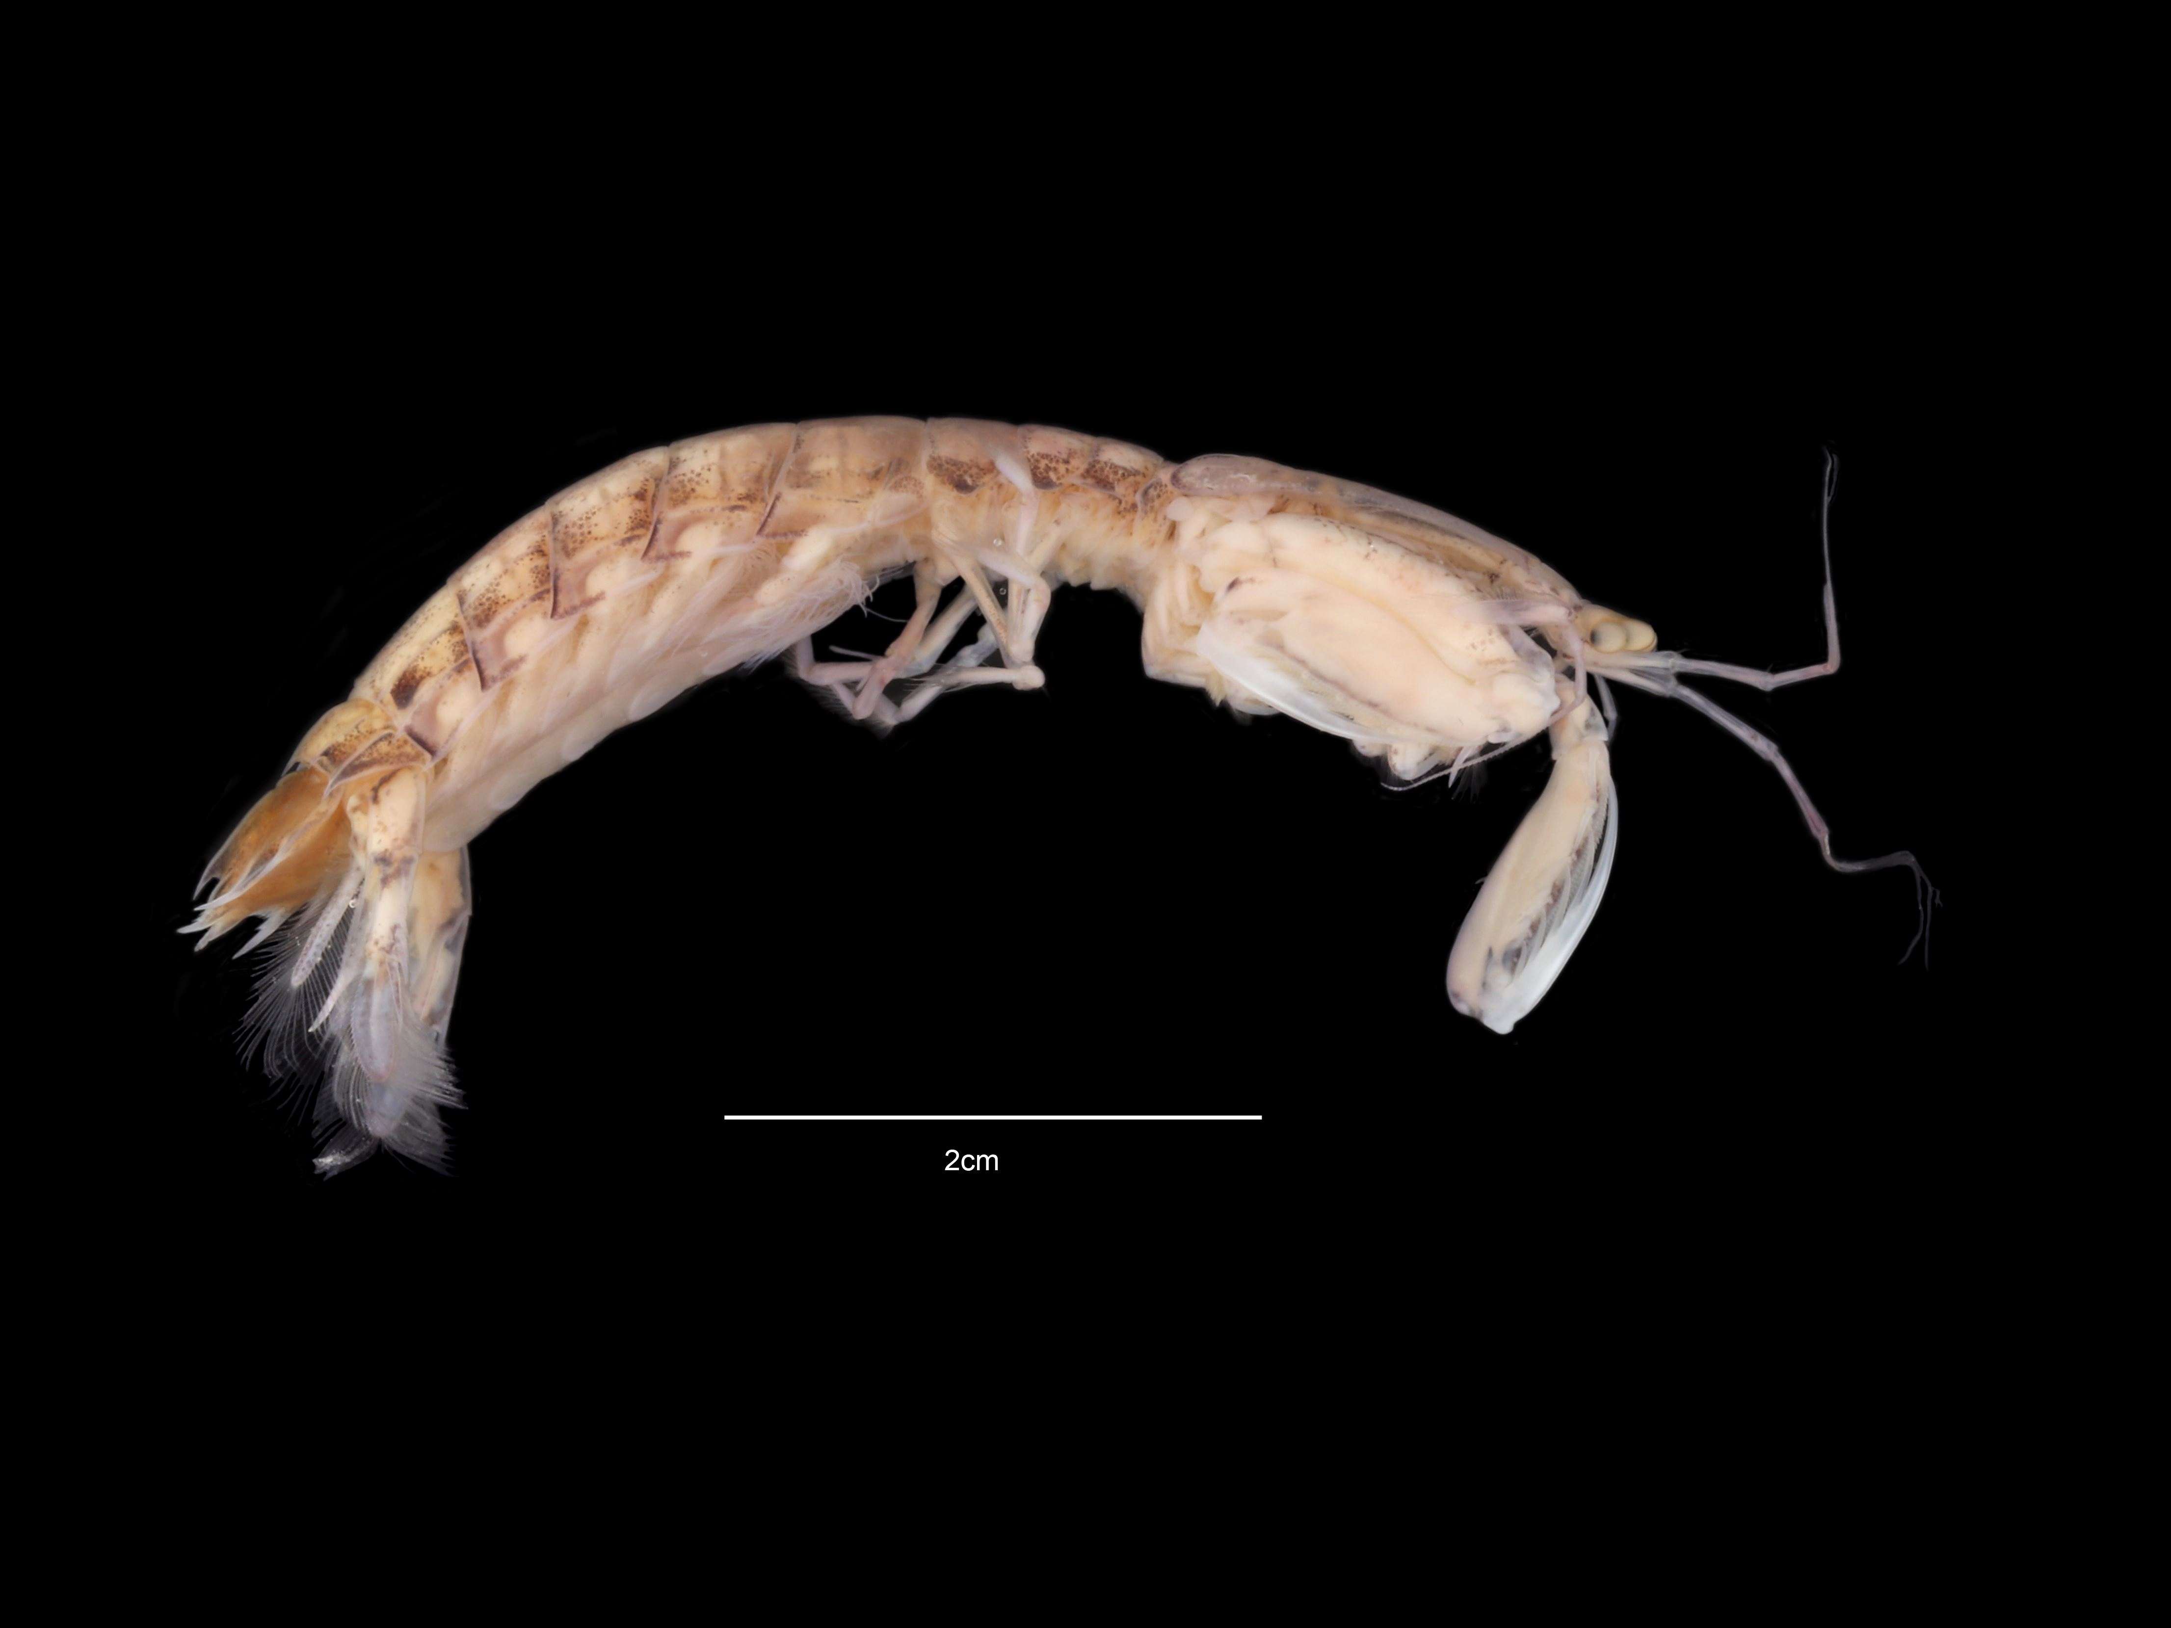 |  | This year we will re-introduce a section on sample processing, with particular emphasis on the extraction of the fauna from the sediment. This will be done, again, with an introductory talk and then a practical observation in our “wet room”.
Rissoides desmaresti ©APEM

The Cost:
The estimated fee for the workshop is £1100+VAT per participant.
Costs cover expert tuition, microscopes and break time refreshments (tea/coffee, etc.) but exclude all meals and accommodation.

Travel Information:
By train: Letchworth Rail Station is directly connected with London Kings Cross and Cambridge. Both ways the average transit time is 35-40 minutes.
APEM laboratory is located approximatively at 14 minutes’ walk from the station, about 5 minutes by taxi.

By car: Letchworth is conveniently located on the A1(M). For SATNAV please use SG6 1ET and once you see “Weldability SIF” use the APEM dedicated buzzer at the barrier. Our building is behind the garage. Note that parking is restricted. The nearest public car park is located 1 minute walk from the laboratory by the Letchworth Outdoor Pool and Norton Common Park (metered).

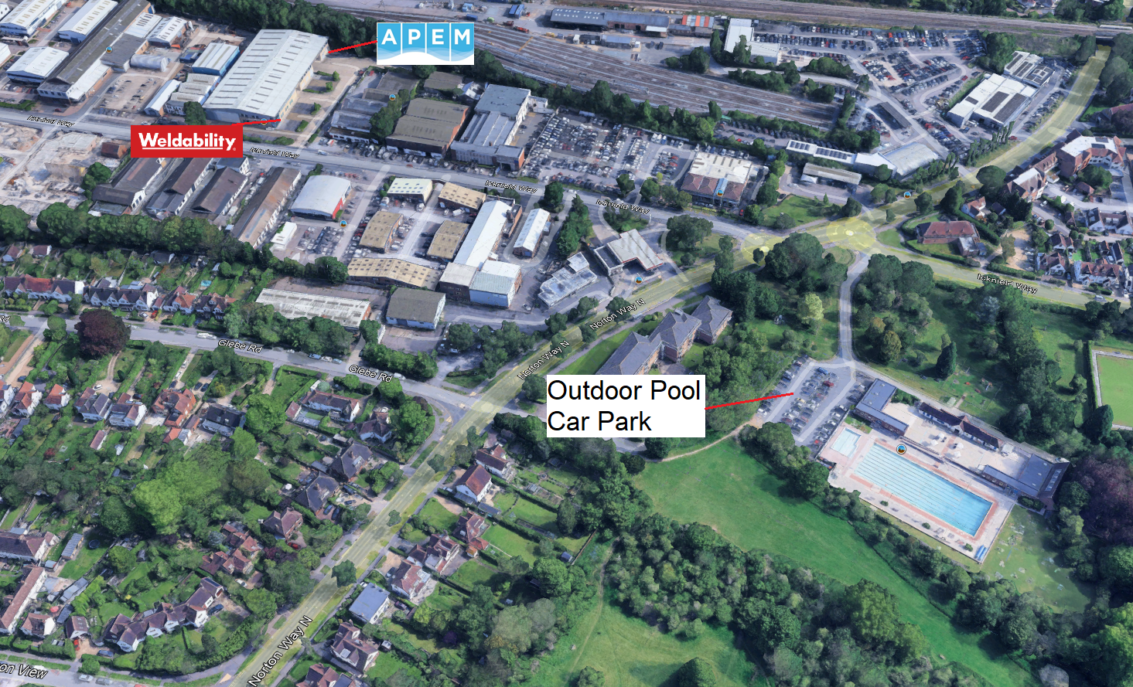

By plane: due to its vicinity to London, Letchworth is well connected to all London airports, although the nearest one is London Luton, immediately followed by London Stansted.

The Accommodation:
A list of accommodations in and around Letchworth is provided below, listed by distance from town centre.

Travelodge Letchworth
https://www.travelodge.co.uk/hotels/662/Letchworth-Garden-City-hotel

Premier Inn Letchworth
https://www.premierinn.com/letchworth

The Broadway Hotel & Carvery
http://www.broadwayhotel.co.uk

Mercure Letchworth Hall Hotel
https://www.accorhotels.com/mercure-letchworth-hall-hotel

Alternatives outside Letchworth:
Letchworth is conveniently located between Hitchin (approximately 4 miles to the west) and Baldock (approximately 2.5 miles to the east). Both towns offer a range of suitable accommodation options, with Hitchin accessible by train and Baldock within walking distance of the APEM Marine Laboratory.

Conditions:
Invoices will be sent upon receipt of a booking form and following confirmation of the workshop in November 2025. The finalised programme will be forwarded as soon as it is available.

Participants will have access to basic microscopes and other equipment (forceps, dishes, alcohol, etc.) but may wish to bring their own laboratory microscopes and cold light sources (equipment requirements must be stated on the booking forms). Please inform us at the time of booking if you will have your own microscope/light source.

Summary:
Single participant = £1100 + VAT

A full workshop timetable will be available soon. Participants should note that the workshop session commences at 10.00 am on the Monday, at 9.00 am the following days, and finish at 5.00 pm every day.

2025 Benthic Invertebrate Taxonomic Workshop for Beginners
Expression of Interest / Booking Form

Name: ……………………………………………………………………………………….....

Laboratory:…………………………………………………………………………………...

I would like to express and interest in place(s) to attend the Taxonomic Workshop for Beginners (please insert number).

I understand that my expression of interest will remain provisional until the workshop is confirmed on 31st October 2025 after this date any cancellations will be non-refundable.

Participant details and attendance options (please complete in full):

 | Participant 1 | Participant 2 | Participant 3 | Participant 4 | Participant 5 | Participant 6
Name
E-mail
Telephone
Taxonomic Workshop 24th- 28th November 2025
Special Requirements
Sub Total £
Total £
Invoice Address
Purchase Order No.

Please return this form by the 27th October 2025 to:
Graham Phillips (Graham.phillips@environment-agency.gov.uk )
Coastal and Estuarine Assessment, Environment Agency, Rivers House, Lower Bristol Road, Bath, BA2 9ES

